REGISTERED COMPANY NUMBER: NI608313 (Northern Ireland)

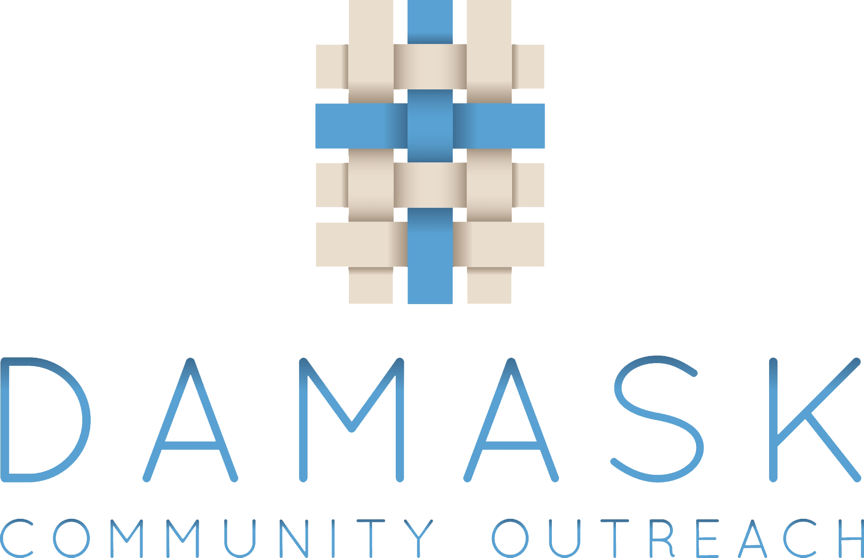

Annual Report of the Trustees and Financial Statements
for the Year Ended 31 March 2020
for
Damask Community Outreach

Damask Community Outreach

Contents of the Annual Report and Financial Statements
for the Year Ended 31 March 2020

Page

Report of the Trustees

Independent Examiner's Report

Statement of Financial Activities

Balance Sheet

Notes to the Financial Statements

Detailed Statement of Financial Activities

Damask Community Outreach

Annual Report of the Trustees
for the Year Ended 31 March 2020

The trustees who are also directors of the charity for the purposes of the Companies Act 2006, present their report with the financial statements of the charity for the year ended 31 March 2020. The trustees have adopted the provisions of Accounting and Reporting by Charities: Statement of Recommended Practice applicable to charities preparing their accounts in accordance with the Financial Reporting Standard applicable in the UK and Republic of Ireland (FRS 102) (effective 1 January 2015).

OBJECTIVES AND ACTIVITIES

Objectives and aims
Damask Community Outreach was formed in July 2011 to work primarily in the community of East Lisburn. The mission statement of Damask Community Outreach is "Dedicated to providing safe, inclusive and challenging opportunities that are changing lives and building futures in our community." The key purpose and services provided by Damask were established in response to an audit carried out in the community. The public benefit delivered by Damask provides support for older people, parents and carers and young people through a range of activities and programmes, together with advice services and support to those experiencing health problems, loneliness, unemployment, age related problems, poverty and financial difficulties.

Damask Community Outreach is a Christian faith-based organisation, working in partnership with Seymour Street Methodist Church, but is open to all and committed to equality of opportunity for all people, regardless of religious belief, political opinion, race, age, marital status, sexual orientation, gender, disability or dependency. Damask is committed to building partnerships in the community, with statutory agencies and with other relevant groups and organisations to ensure that it can offer a wide range of services that match the needs of the community and help with the personal development of individuals.

Volunteers and Staff
Damask Community Outreach is very largely dependent on the service provided by our team of trained and dedicated volunteers comprising the Damask Board and leadership and support teams our activities. We are truly blessed by this band of faithful people who serve so willingly and unstintingly on a daily basis allowing the Damask to direct its resources to they are needed most. We also have a small number of professional staff providing the Advice Service, Counselling and Youth Programmes. The youth programme is also supported by a full-time and a part time Youth Initiatives staff member.

There are currently approximately 60 volunteers contributing the volunteer hours summarised in the table below showing year on year volunteering hours with Damask Community Outreach:
2019/20 2018/19 2017/18
Youth Projects 2160 1800 1464
Advice Service 750 900 1162
Befriending Service 80 120 624
Community Services 567 818 648
Management & administration 1008 1056 1200
Car Boot Sale 400 400
Storehouse collection 150 192

Total 5115 5286 5098

Ensuring the Work Delivers the Aims of the Company
The aims, objectives and activities are reviewed throughout the year at Damask Board Management meetings held monthly, looking at what has been achieved and the outcomes of the work. The effect of each key programme and service and the benefits they have brought to the community and the groups are reviewed systematically. This process helps ensure that aims, objectives, programmes and services remain focused on the stated purposes. The Board refers to the guidance contained in the Charity Commission's general guidance on public benefit when reviewing its aims and objectives, and in planning its programmes and services.

Objectives for 2019/20
The main objectives for the 2019/20 have continued to relate primarily to supporting families including older people, parents and carers and young people, those experiencing health problems, loneliness, unemployment, age related problems, poverty and financial difficulties. All the charitable activities focus exclusively on meeting needs and providing support in the local community and are undertaken to further our charitable purposes for the public benefit and within the criteria that defines public benefit outlined in the statutory guidance.

In additional the Damask Board aimed to bring the annual balance sheet for 2019/20 into credit, as over the last few years it Damask had been in deficit and the financial reserves of the organisation had been depleted significantly.

Programmes and Activities

While the full Damask programme of activities was maintained for most the financial year, the emergence of the COVID Pandemic resulted in the termination of all our activities within the Seymour Street premises from Monday 16th March 2020, and also cancellation of the Car Boot sale due to be held on Saturday 14th March.

YOUTH PROJECTS (in association with Youth Initiatives)

The main emphases of the youth programme led by Youth Initiatives over the 2019/20 year was to build their relationships with both the younger and old young people from our area and support them in their personal development, education and life skills.

At the heart of the Youth Initiative’s programme is the Outreach Project which continued its detached youth work on the streets of Lisburn, but as a result of the difficulties of maintaining adequate supervision we did not open the Seymour Street Halls on a Saturday night, instead encouraging older teens to join the Transform Programme being run for them on a Friday evening.

There is a clear need for continuation of this outreach that connects with young people across Lisburn who continue to congregate in certain areas and cause disturbance to the local community, and we are continually challenged as to how best to meet this need in a way that supports and progresses young people in their lives. The PCSP continue to provide financial support for this outreach work from their ‘Intervention’ programme, and Damask is one of only two organisations in the Lisburn and Castlereagh Council area to be given priority funding of this type.

During the week Youth Initiatives opened a young men’s and young women’s programme night for our 15 - 18 year olds. This provided space for those from the local community to get involved with various personal, social development and good relations programmes, completing 3 OCNs: in Handling Conflict, Good Relations & Diversity, and Practical Youth Leadership Skills.

This also provided opportunities for recruitment into the Year 3 Transform Programme which began in January 2020. This year the Transform programme involved 9 young people who will aim to completed over 250 hours of programming on personal & social development, good relations and active citizenship. So far they have completed the Targeted Life Skills programme, and will work with our partner group in West Belfast to complete another OCN (LV 2 Personal Success & Wellbeing), will attend a YI Summer Camp, and lead a 2 week Summer Scheme for 10-14 yr olds from the local community based at Seymour Street.

The “GO” project (formerly “STRETCH”) on Thursday afternoons continues to work with our 10-14 year olds, and is our fastest growing programme with over 40 young people registered. The aim is to target issues expressed by our young people such as mental health awareness, bullying, community care, identity and purpose, all done in a fun, interactive and challenging way.

The year has seen steady growth as we seek to establish a Youth Community Hub at Damask Community Outreach. To facilitate this a Memorandum of Understanding between Damask and Youth Initiatives has been agreed and regular meetings planned. Our vision for youth and community work here in Lisburn is of a faith-based community of people, led by God, working to inspire hope and initiative in young people, so that they can use the diverse gifts and abilities they have been given to transform both their own lives and the lives of those in their communities.

We are already planning for next year when our focus will be to challenge young people to explore their identity, to consider faith and spiritual development, to provide more opportunities to learn skills and gain qualifications and create a Kingdom community of adults and young people who want to have a positive influence on those around them. Our main objectives will be to expand both our 10-14s and 15-18s work to include a both a drop-in and programme night, and we hope to develop a programme looking at faith exploration and discipleship.

Links
We have continued to develop strong relationships with a number of organisations. These include: CAP Lisburn, Lisburn & Castlereagh City Council, PSNI, Storehouse, Exodus, SALT Factory Sport, Police and Community Safety Partnership, Youth Link and Youth For Christ. These organisations have been supportive and have enabled Damask to deliver more challenging and successful projects.

ADVICE SERVICE

The Damask Advice Service continues to make huge strides in improving the lives of individuals and families, many of whom are vulnerable and disadvantaged, both socially and economically. We continue to offer a wide range of Welfare benefit advice every week e.g. Family support, Personal Independence Payment, Attendance Allowance, Health and Disability, Jobseekers Allowance, Employment Support Allowance and Housing Benefit. Help is given on these issues by Therese Milligan on 2 days per week. Furthermore Sue Stevenson from Advice NI provides advice on Tax and Tax credit issues one day per week.

There has been a further significant increase in members of the local Lisburn community and beyond using this service. In some cases clients turn to us because no other agency is able to provide them with support. By the links Damask has developed with Rikki Keag in counselling and also with a qualified health coach who is providing additional free sessions, and through our association with the Pastoral Care team in Seymour Street Methodist Church, and with the Storehouse food bank we are able to provide help in a much wider range of scenarios than other support agencies. This year Rikki saw a total of 19 clients referred from our General Advice Service and provided 98 sessions of counselling.

General Advice 2018/19 2017/18
Clients helped 613 544
Enquiries, Appointments & Home Visits 987 924

There are people from our community who present for issues that are outside our remit which we refer to more specialist organisations.

We are very grateful to our faithful band of volunteers who act as receptionists and carry out varied administration responsibilities without whom it would be difficult to deliver the high level of service we do which amounts to in excess of 900 hours annually.

Debt Advice Service
Just before the end of March 2019 Damask was approached by Advice NI regarding the possibility of taking on provision of Debt Advice for the Lisburn and Castlereagh City Council area with Government funding through the Department of the Communities. A meeting was help with Advice NI and it is possible that Damask may undertake this during the next financial year.

BEFRIENDER SERVICE
Due to the retirement of a number of volunteers the Befriender Service has been scaled back over this year and we have currently only two Befrienders making regular visits to their clients. However there continues to be a need for this service to the elderly and housebound. A number our clients have described the service as fantastic and the befrienders as real friends. Damask will continue to review this situation and seek to find additional volunteers who will be provided with appropriate training prior to matching the volunteer with a client.

TODDLER GROUP
The Toddler Group has continued to thrive this year. Meeting on Wednesday mornings during Term Time and have an average attendance of 35 to 40 children with a similar number of parents/carers/child minders.

We aim to give both children and adults an enjoyable morning. Every week we have a time of free play, a craft activity where the children make something to take home, snack time for both children and adults, and song time. We try to have some home baking or nice cake for the adults so as coming to Toddlers is a bit of a treat!

There are 6 volunteer leaders and we begin the morning with prayer, praying that we will have opportunity to share God’s love with those we meet at Toddler Group. Many friendships have developed within the group and it is always a joy to see some of our Toddlers grow up and join our church organisations like the Boys’ Brigade and Girls’ Brigade.

TEA DANCES
The Damask Tea Dances are a very popular event. They take place monthly and there have been about 45+ participants each week, slightly down on last year. The event provides a place for good social interaction, friendship, fun and exercise. The music is provided by well-known local musician 'Housty' with his varied repertoire of music that suits the generation who attend. Guests are provided with tea, scones and tray bakes. This for many is their monthly outing which provides opportunity for social interaction for those who have been widowed or live alone, it provides light exercise and is a fun afternoon. Opportunities have been taken to inform participants of the services that are available by Damask such as the Advice Service, counselling service and storehouse food bank. There is an entrance fee of £4 per person which is just sufficient to cover the running costs.

ARM-CHAIR PILATES
This year a new activity supported by Damask has been Arm-chair Pilates which takes place for about 30 minutes prior to each meeting of the Seymour Street Luncheon Club. With a grant from Lisburn Safe and Well the services of a qualified coach has been provided. Exercise such as pilates provides documented health benefits to senior citizens who might not otherwise have any regular form of exercise. About 12 people attend the Pilate class every two weeks.

FOOD BANK
Damask Community Outreach recognises the valuable service offered by foodbanks and continues to collect food for the Storehouse project, based in Dunmurry. Food is collected on a weekly basis from Seymour Street Methodist Church and other outlets and delivered to the main warehouse. This food is then distributed, along with other food, to those in need. During the year Damask distributed on average one bag of food per week through referrals from the Advice Service and other agencies in the East Lisburn area.

DAMASK CAR BOOT SALE
Although primarily organised as a fund-raising activity to support DAMASK the monthly indoor Car Boot Sale has also become an important and well attended community activity. Volunteers sell refreshments and hot-dogs and many items donated by church members and others are sold at a ‘Damask’ table to raise funds. Other tables are set up selling everything from jam, cakes and pot plants to clothes, toys and crafts. A wide cross- section of people from the local community drop in to each sale and the sales gives DAMASK are higher profile.

OTHER EVENTS

'Fallfest' which promotes a less ‘spooky’ alternative to Halloween has become a regular event in the Damask Community Outreach calendar. We run this in partnership with Seymour Street Methodist Church attracting over 150 children and young people plus parents and is offered as a diversionary activity from some of the unsocial activities which occur in the Community at Halloween.

'Refresh' is another event that is run in partnership with Seymour Street Methodist Church which is a summer activity club mainly for primary aged children. Over the last few years this went 'Green' and we moved the event out of the Seymour Street Halls onto the 'Green' at Roseville Park. It continues a highly successful event.

FUTURE PLANS
As a serious provider of services Damask Community Outreach will continue to consolidate the services offered and will keep all our provision under review in order to deliver our social outreach programme in the most effective and efficient way through partnering Seymour Street Methodist Church, Youth Initiatives and other agencies operating in the area.

APPRECIATION AND WELCOME
The Damask Board wish to place on record our deep appreciation and thanks to all our Volunteers who give of their time so freely.

Damask Community Outreach

Report of the Trustees
for the Year Ended 31 March 2020

Principal Funding Sources
The principal funding source is by way of grant income and Damask Community Outreach is grateful to the following organisations that provided funding for activities during the period covered by this report:

- SEH&SCT Safe & Well Resources for Older People
- Lisburn & Castlereagh City Council
- PCSP
- Seymour Street Methodist Church
- Halifax Foundation

In addition Damask Community Outreach acknowledges the following organisations that assisted with advice, support and training:

- Seymour Street Methodist Church
- Carson McDowell (Solicitors)
- NICVA
- Advice NI
- The Law Centre
- South Eastern Health & Social Care Trust
- Department Of Social Development NI
- Business In The Community NI

Staff
The Board also express their thanks to Therese Milligan Advice Service, Sessional Worker, Sue Stevenson placement from Advice NI, Rikki Keag Counsellor, Ryan Lilley and David White Youth Leaders seconded from Youth Initiatives and Michael Croft placement from Centre for Youth Ministry.

Financial Review and Reserves Policy
In partnership with our principal funders as detailed in the notes to the financial statements we delivered an agreed programme. The amount directly expended on charitable activities in the 12 months to 31 March 2018 amounted to £28,945 (£34,375 March 2017)

We maintained tight control over our finances and are seeking to establish a reserves policy, which will maintain the financial stability of the charity.

We will continue to keep our Principal Funders fully informed through briefing and progress reports to agreed timetables.

Finances
The Statement of Financial Activities on Page 13 reflects a deficit of £6,140 Incoming Resources over Resources Expended. The Unrestricted Funds carried forward at 31 March 2018 amount to £20,147 (£25,938 at 31 March 2017). The Restricted Funds carried forward at 31 March 2018 amount to £0 (£0 at 31 March 2018). The Toddler Group reserve carried forward at 31 March 2018 amount to £404 (£754 at 31 March 2017). Totalling overall funds carried forward of £20,551 (£26,692 at 31 March 2017).

Risk Management
The Board continue to review the major risks to which the charity is exposed and they endeavour to maintain control procedures and systems to mitigate those risks.
Damask Community Outreach Report 2018/19

Responsibilities of the Board of Directors
Company Law requires the Board to prepare financial statements for each financial year that give a true and fair view of the state of affairs of the charitable company as at the balance sheet date and of its incoming resources and applications of resources, including income and expenditure, for the financial year. In preparing those financial statements the Board follows best practice and selects suitable accounting policies, makes judgements and estimates that are reasonable and prudent and prepares financial statements on the going concern basis, unless it is not appropriate to assume that the company will continue on that basis.

The Board of Directors is responsible for maintaining proper accounting records which disclose with reasonable accuracy at any time the financial position of the charitable company and to enable them to ensure that the financial statements comply with all legal obligations. The Board of Directors is also responsible for safeguarding the assets of the charitable company and therefore for taking reasonable steps for the prevention and detection of fraud and other irregularities.

STRUCTURE, GOVERNANCE AND MANAGEMENT

Governing Document
The charity is controlled by its governing document, a deed of trust, and constitutes a limited company, limited by guarantee, as defined by the Companies Act 2006.

Damask Community Outreach is a charitable company limited by guarantee, incorporated on 22 July 2011 and registered as a Charity by the Charity Commission Northern Ireland NIC102073 on 6 March 2015. It is recognised by HMRC as a charity for tax purposes. The company was established under a Memorandum of Association, which established the objects and powers of Damask as a charitable company, and is governed under its Articles of Association.

The Articles of Association were amended by a Special Resolution of the Company at a Special General Meeting held on 21 October 2013.

Recruitment and appointment of new trustees
The Directors of the company are also known as charity trustees and under the Company's Articles are known as the Board. Members of the Board are elected by the decision of the Directors, or by an ordinary resolution. All members of the Board of Directors give their time voluntarily and receive no benefits from the charity. At present there are eight Board members who have served during this past year who are listed on page 8. The Board seeks to ensure that there is an appropriate mix of skills within the trustee body, and that it adequately reflects the nature and diversity of the work of the company.

Organisational Structure
The Damask Community Outreach Board of Directors, who met 3 times during the year, is responsible for the strategic direction and policy of the charity.

A scheme of delegation through an established management structure is in place. During the period of this report the Advice Service was managed by Jim Irwin, the Youth Programme by Rev Mervyn Ewing (to January 2019 and by Dr Lindsay Easson (February and March 2019), and the Toddlers, Tea Dance and Befriending by Shirley Carrington. Each of these Board Members reported to the Board on these areas at each Board meeting.

Induction and training of new trustees
Trustees are encouraged to familiarise themselves with the obligations of membership of the Board of Directors. They are also encouraged to be aware of charity legislation, to attend training relevant to their position and be aware of the current financial position, resourcing, future plans, objectives, policies and procedures of the company.

Damask Community Outreach Report 2018/19

REFERENCE AND ADMINISTRATIVE DETAILS
Registered Company number
NI608313 (Northern Ireland)

Registered Charity number
102073

Registered office
16 Adlon Crescent
Lisburn
Co. Antrim
BT28 2EG

Trustees
Mrs Shirley Anne Carrington
Dr David Lindsay Easson (Chairman, from February 2019)
Mr James Edward Irwin
Rev Mervyn George Ewing (Chairman, to January 2019)
Mr William Eric Rainey
Ms Anne Teresa Maxwell
Miss Jennifer Michelle Baird (Treasurer)
Mr Don Kinghan

Independent examiner
McCleary & Company Ltd
Ratheane House
32 Hillsborough Road
Lisburn
Co. Antrim
BT28 1AQ

Bankers
Danske Bank
PO Box 183
Donegal Square West
Belfat
BT1 6JS

Damask Community Outreach

Report of the Trustees
for the Year Ended 31 March 2018

REFERENCE AND ADMINISTRATIVE DETAILS

Solicitors
Carson & McDowell
Murray House
4 Murray St.
Belfast
BT1 6DN

Approved by order of the board of trustees on ............................................. and signed on its behalf by:

.............................................
Trustee

